Abstract

This abstract presents an overview of an automatic boiler system designed and implemented using Mitsubishi Programmable Logic Controller (PLC) technology. Boilers are critical industrial devices used for generating steam or hot water for various applications. Automation of boiler systems enhances efficiency, safety, and operational control. The integration of Mitsubishi PLC technology provides a reliable and sophisticated solution for achieving these goals.The automatic boiler system employs Mitsubishi PLCs to control and monitor various aspects of the boiler operation. The system consists of sensors, actuators, control logic, and a pump. Sensors continuously gather data on parameters such as temperature, pressure, and water level. This real-time data is processed by the Mitsubishi PLC, which then executes control algorithms based on predefined logic.

CHAPTER ONE
1.0 INTRODUCTION
1.1 BACKGROUND OF THE STUDY
The industrial sector relies heavily on energy sources, with steam being a crucial utility for various processes, including heating, power generation, and chemical reactions. Boilers play a pivotal role in producing steam, making them essential components of industrial facilities. To optimize energy consumption, operational efficiency, and safety, the integration of programmable logic controllers (PLCs) into boiler systems has become a prevalent trend.
Boiler systems are complex and critical components in various industries. Manual operation of boilers can lead to inefficiencies, safety hazards, and increased energy consumption. Automation aims to address these challenges by enabling continuous monitoring, precise control of parameters (such as temperature, pressure, and fuel input), and timely adjustments to ensure optimal performance.
Industrial automation has revolutionised manufacturing processes by introducing advanced control systems that streamline operations, enhance precision, and reduce human intervention. PLCs are at the heart of industrial automation, providing real-time control, monitoring, and data processing capabilities. They are particularly well-suited for applications requiring repetitive, precise, and complex control sequences, making them an ideal choice for managing boiler systems.
Mitsubishi Electric is renowned for its advanced PLC technology, which offers high-performance control, exceptional reliability, and user-friendly programming interfaces. Mitsubishi PLCs are equipped with various communication protocols, digital and analog I/O modules, and the capacity to interface with human-machine interface (HMI) systems. These features make Mitsubishi PLCs a suitable choice for building sophisticated and efficient boiler control systems.

1.2 AIM AND OBJECTIVES OF THE STUDY
Aim
The aim of the Boiler System using PLC is to design, develop, and implement an automated and efficient boiler control system utilizing Programmable Logic Controller (PLC) technology. The primary goal is to enhance the operational efficiency, safety, and reliability of the boiler system while minimizing energy wastage and human intervention.

Objectives:
The objectives of the Boiler System using PLC project are as follows:
1. Automated Control:Develop a control system that automates the operation of the boiler, including ignition, heat input regulation, water level control, and pressure regulation, using Mitsubishi PLC technology.

2. Safety Integration: Implement safety protocols and interlocks using PLC logic to respond to abnormal conditions, such as high pressure or low water levels, ensuring the safe operation of the boiler and preventing potential hazards.

3. Fault Detection and Diagnostics: Develop algorithms within the PLC to detect and diagnose faults, anomalies, and operational irregularities, providing maintenance personnel with actionable insights for prompt troubleshooting.
4. Adaptive Operation: Design the PLC control system to adapt to varying loads and operational conditions, ensuring optimal performance across different production scenarios without manual intervention.
5. Documentation and Training: Develop comprehensive documentation for the PLC-based boiler system, including operation manuals, maintenance guides, and training materials to ensure proper system understanding and management.

6. Integration with Existing Infrastructure: Integrate the PLC-based boiler control system seamlessly with the existing plant infrastructure, ensuring compatibility and minimizing disruption during installation and commissioning.

7. Performance Validation: Conduct thorough testing and validation of the PLC control system under various operating conditions to ensure that it meets the specified performance criteria and objectives.

By achieving these objectives, the project aims to create a state-of-the-art Boiler System using PLC technology that not only enhances the efficiency and safety of boiler operations but also contributes to reduced energy consumption, improved product quality, and operational excellence in industrial settings.
1.3 Scope and Limitation
The scope of the Mitsubishi PLC-based automatic boiler system encompasses various aspects of design, implementation, operation, and benefits. The system aims to revolutionize boiler operations by leveraging Mitsubishi's advanced PLC technology to enhance efficiency, safety, and control in steam generation processes. The following outlines the key components of the system's scope:

System Design:
- Development of a comprehensive control strategy for automated boiler operation.
- Selection of appropriate Mitsubishi PLC hardware and peripherals for the system.
- Integration of safety interlocks and protocols to prevent hazardous conditions.

Automation and Control:
- Implementation of PLC-based algorithms for real-time control of boiler parameters, such as temperature, pressure, and heat input.
Safety Enhancement:
- Incorporation of safety interlocks and emergency shutdown protocols to prevent dangerous situations.
- Implementation of alarms and notifications to alert operators about abnormal conditions.
- Integration with safety systems to ensure compliance with industry standards and regulations.
Integration and Scalability:
- Evaluation of compatibility with existing control systems and potential for integration.
- Consideration of system scalability to accommodate future expansions or modifications.
Limitations of Mitsubishi PLC-Based Automatic Boiler System:
- Initial Investment: Implementing the system involves upfront costs for Mitsubishi PLC hardware, programming, and system integration. The initial investment might be a barrier for some organizations.
- Complexity: Designing and programming a PLC-based system requires expertise and time. Complex algorithms and interlocks need careful consideration and testing to ensure optimal performance.
- Maintenance and Support: While PLC systems are generally reliable, maintenance and technical support are necessary to address potential hardware or software issues that may arise over time.
- Human Intervention: While the system minimizes human error, it still requires skilled personnel for maintenance, troubleshooting, and occasional manual intervention.
- Process Complexity: While the system can handle many boiler operations, extremely complex processes may require additional specialized control systems.
- Dependence on Technology: The system's performance relies on the reliability of Mitsubishi PLC technology. Technical advancements or changes to the technology could impact the system's long-term viability.
- Training: Operators and maintenance personnel need appropriate training to effectively operate and maintain the system.

1.4 BENEFITS OF THE STUDY
The study of a Mitsubishi PLC-based boiler system brings forth a multitude of benefits that positively impact industrial operations, safety, efficiency, and sustainability. It offers a compelling case for adopting advanced automation solutions to enhance boiler operations in modern industrial settings.

1.5 RESEARCH QUESTION
- How do you use a Mitsubishi PLC?
- What is PLC Mitsubishi?
- What software does Mitsubishi PLC use?

1.6 APPLICATIONS OF THE STUDY
The areas of application of this device are as below:
- Power Generation Plants
- Chemical Industry
- Food and Beverage Industry
- Textile Industry
- Oil and Gas Industry
- Automotive Industry
- Hospital and Healthcare Facilities
- HVAC Systems
- Renewable Energy
- Textile and Garment Industry

CHAPTER TWO
2.0 LITERATURE REVIEW

2.1 REVIEW OF RELATED STUDIES

Chandrashekar S.G., Dr. K.V. Mahendra PrashanthMarch 2015, depicts the utilization of PLC for the checkingand filling of tablets for pharmaceutical application. Theygives the contrast between utilization of small scale controllerand PLC as miniaturized scale controllers are less adaptable toelectrical clamor, vibration, and temperature. What's more,PLC is made for various simple and advanced information,yield, better in broadened temperature extents, clamor andvibration. They clarified the point by point procedure of theirframework. The venture is isolated into two sections 1.Equipment plan and 2. Programming plan. In which everysegment measurement and determination are given. Theyutilized three metal adapted 24 V DC ,DC motor which hasevaluated torque - 15 kg-m and appraised speed – 15 rpm,current – 0.5A.PLC utilized is Rexroth Indra Logic L 20Bosch gathering and IR sensors utilized of 5V DC to identifythe compartment. 4 no. transfers utilized 3 of 24 V DC and 1of 5 V DC. The framework gave more accuracy and lesswastage of tablets.

Mallaradhya H.M., K.R. Prakash Oct-2013, they builtup an arrangement of programmed bottle filling of varioustallness through PLC coordination. Amid their examinationthey characterized the issue which is to be settled i.e. there areframework no one but which can fill a specific heighted holderand subsequent to discovering they construct one. As normalutilized three capacitive sorts of Proximity sensor sensors, ACsynchronous DC motor, and solenoid valve. For the wellbeingof PLC yield of sensors is not straightforwardly given to thePLC firstly it is flag adapted circuits by utilizing transferswhich comprises three terminals normal, NO and NC. Withrespect to yield gadgets from PLC utilized transfer drive unitconcerning DC motor input voltage is 12 V. The filling ofholder is just in view of the planning of the solenoid valve sofor the filling distinctive size compartment they change timingin the program

Bhise et al (2015) proposed an embedded PLC for teaching students. Authors combined LabVIEW software and the AVR Microcontroller with the VB modules to achieve the embedded PLC built bottle filling plant for it application. The programming language used for the embedded PLC is the FB. Although the embedded PLC setup is flexible, relatively easy and affordable to teach the basic principle for PLCs, they did not present or discuss FB program for the bottle filling application. Also, survey report of their application shows moderate performance in stability and reliability.
Mahadi et al (2015) proposed a PLC Trainer Kit Simulator Automation Lab at the Polytechnic of Sultan Abdul Halim Mu’adzam Shah (POLIMAS). The training kit comprises the Omron PLC CPU unit with 12 inputs and 8 outputs control. Input and output devices are bank of switches and light indicators respectively. They used CX- Programmer for CP1E version 1.0 to program the PLC using ladder diagram and instruction list PLC programming languages. The fabrication of a multiple input/output (I/O) PLC module for educational purpose to enhance the learner’s theoretical comprehension and hands-on skill especially for programming, cabling, circuit design and problem solving according to Ibrahim et al (2015). Their module consists of I/O devices such as push buttons (normally open), DC motor (24V), DC relay (24V), DC solenoid piston cylinder (24V) and DC light (24V) capable of interfacing with PLC controller produced by Matsushita, Omron, Siemens. Survey report from the trainees show that 95.70 % attest to the enhancement in their theoretical comprehension and hands-on skill competence in their learning process.
Sukir et al (2019) proposed a PLC Based Electrical Machine Trainer Kit developed for Electrical Engineering Practices in the Department of Electrical Engineering Education at Faculty of Engineering, Universitas Negeri Yogyakarta. Their approach is research and development with reference to the ADDIE model from RobertMaribe Branch. The installed PLC is Zelio SR2.201FU and the console dimension is 44.1 cm ×100 cm and 92.7 cm ×100 cm with a front tilt angle of 80 °. Authors examined the performance of trainer kit on 8 practical experiment; rotation control of DC motors; rotation control of three phase induction motor; rotation control of one phase induction motor; starting DC motor; starting 3 phase induction motor using auto-transformer; dynamic DC motor braking; DC motor braking by plugging; and braking 3- phase induction motor by DC injection. Result show the trainer kit has a good performance, indicated by the electrical components and the practical work description can function appropriately as planned. They used the Delta DVP14SS2 PLC, WPLSoft software and switches as inputs and pilot lamps as outputs. Instructors trained student on cabling and programming of PLC with hands-on training on Traffic light automation application. Authors carried out pre and post training evaluation for trainee and result show significant improvement of about 45.8% in the trainees’ capacity to wire and program a PLC for automation control.
Samanol et al (2014) analyze "Development of pneumatic trainer kits for polytechnic students," which produces pneumatic trainer kits for learning the basics of pneumatics for students of the Department of Engineering, Seberang Perai Polytechnic, Malaysia. These studies differ from this particular research, in terms of trainer kit products and use.
Related to research on Programmable Logic Controllers (PLC), Akparibo John (2016) conducted a study entitled "Development of a programmable logic controller training platform for the industrial control of processes." The research obtained an interactive, cheaper and more portable PLC trainer kit for industrial process control simulations. The PLC Trainer kit

2.2 Block Diagram of the system

Power Supply

Mitsubishi

PLC

Temp
Sensor

Level Sensor

Pump

Heater

Fig 2.1: Block diagram of automatic boiler system

Power Supply Unit :

Designing a 24V DC power supply involves creating a circuit that takes in an input voltage (usually from the AC mains 220v) and converts it into a stable 24V DC output.
Components Needed:
- Transformer: Converts high-voltage AC input from the mains to a lower-voltage AC.
- Rectifier: Converts the step down AC to pulsating DC.
- Filter Capacitor: Smoothens the pulsating DC into a more constant DC voltage.
- Voltage Regulator: Stabilizes the DC voltage to 24V.
- Output Capacitor: Further filters the output voltage for reduced ripple.
- Protection Circuitry: Includes components like fuses and protection diodes for safety.

Temperature transmitter Unit
A temperature transmitter is a device used to measure temperature and convert it into a standardized output signal that can be used for monitoring, control, and communication purposes. It's commonly used in industrial processes and automation systems where accurate temperature measurement and control are critical.

The Mitshibushi PLC Unit:
Mitsubishi Electric is a well-known company that manufactures a wide range of automation and control products, including Programmable Logic Controllers (PLCs). Mitsubishi PLCs are widely used in industrial automation for controlling processes, machinery, and equipment. They offer various series and models of PLCs designed to suit different application requirements.

Mitsubishi PLC Features and Components:
- CPU (Central Processing Unit):The CPU is the brain of the PLC. It processes logic and executes control functions based on the program loaded into it.
- Digital and Analog Input/Output Modules:These modules interface with sensors, switches, actuators, and other devices in the field.
- Communication Modules:Mitsubishi PLCs support various communication protocols for connecting with other devices, networks, and control systems.
- Programming Software:Mitsubishi PLCs are programmed using software such as GX Works3 or GX Developer. These software tools offer a user-friendly interface for creating, testing, and debugging ladder logic or other programming languages supported by the PLC.
- HMI Integration: Mitsubishi PLCs can be integrated with Human-Machine Interfaces (HMIs) for creating visual interfaces to interact with the control system.
- Safety Functions:Some Mitsubishi PLC models include safety features that enable safe operation in industrial environments. These safety functions can include emergency stops, safety interlocks, and more.
- High-Speed Counting and Positioning: Mitsubishi PLCs can handle applications requiring high-speed counting and precise positioning, making them suitable for motion control tasks.

Level Sensor Unit:
A conductivity level sensor is a type of level measurement device used to determine the level of a liquid or substance within a container or tank based on its electrical conductivity. It operates by detecting changes in the electrical conductivity of the liquid, which is influenced by the concentration of dissolved ions or particles within the liquid.

The "two point" aspect of this sensor refers to the two predefined conductivity levels at which the sensor triggers specific actions or measurements. These levels are typically categorized as low level, and high level. When the liquid reaches each of these levels, the sensor responds in a certain way, often by activating alarms, control systems, or pumps.

Here's how the two-point conductivity level sensor generally works:

1. Low Level: When the liquid level drops to the low level point, the conductivity sensor detects a decrease in electrical conductivity. This could be due to the fact that less of the liquid is in contact with the sensor's electrodes, leading to a weaker electrical signal. This trigger might initiate actions like activating a pump to refill the tank.

3. High Level: When the liquid level reaches the high level point, the electrical conductivity is at its highest, as more of the liquid is in contact with the electrodes. This trigger can lead to actions such as shutting off a filling process or activating an overflow alarm to prevent spillage.

Heating Unit:
A heater unit is designed to generate heat and raise the temperature of the process boiler, the heater is controlled by the PLC automatically when the temperature of the process heats a certain setpoint.

2.3 Review of Components of the system

2.3.1 The Programmable Logic controller (PLC)
Programmable Logic Controllers continuously monitors the input values from various input sensing devices (e.g. accelerometer, weight scale, hardwired signals, etc.) and produces corresponding output depending on the nature of production and industry. A typical block diagram of PLC consists of five parts namely:
- Rack or chassis
- Power Supply Module
- Central Processing Unit (CPU)
- Input & Output Module
- Communication Interface Module

Rack or Chassis
In all PLC systems, the PLC rack or chassis forms the most important module and acts as a backbone to the system. PLCs are available in different shapes and sizes. When more complex control systems are involved, it requires larger PLC racks.
Small-sized PLC is equipped with a fixed I/O pin configuration. So, they have gone for modular type rack PLC, which accepts different types of I/O modules with sliding and fit in concept. All I/O modules will be residing inside this rack/chassis.
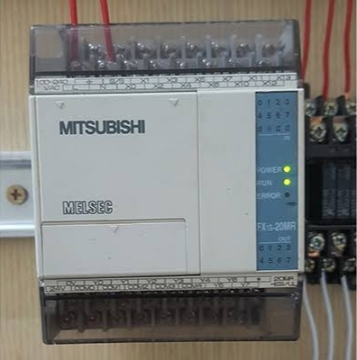

fig 2.2: Pictorial representation of PLC

Power Supply Module
This module is used to provide the required power to the whole PLC system. It converts the available AC power to DC power which is required by the CPU and I/O module. PLC generally works on a 24V DC supply. Few PLC uses an isolated power supply.

CPU Module and Memory
CPU module has a central processor, ROM & RAM memory. ROM memory includes an operating system, drivers, and application programs. RAM memory is used to store programs and data. CPU is the brain of PLC with an octal or hexagonal microprocessor.
Being a microprocessor-based CPU, it replaces timers, relays, and counters. Two types of processors as a single bit or word processor can be incorporated with a PLC. One bit processor is used to perform logic functions. Whereas word processors are used for processing text, numerical data, controlling, and recording data.
CPU reads the input data from sensors, processes it, and finally sends the command to controlling devices. DC power source, as mentioned in the previous discussion is required voltage signals. CPU also contains other electrical parts to connect cables used by other units.

Input and Output Module
Have you ever thought about how to sense physical parameters like temperature, pressure, flow, etc? using PLC? Of course, PLC has an exclusive module for interfacing inputs and output, which is called an input & output module.
Input devices can be either start and stop pushbuttons, switches, etc and output devices can be an electric heater, valves, relays, etc. I/O module helps to interface input and output devices with a microprocessor.

- TYPES OF PROGRAMMABLE LOGIC CONTROLLER
The two main types of PLC are fixed / compact PLC and modular PLC.

Compact PLC
Within a single case, there would be many modules. It has a fixed number of I/O modules and external I/O cards. So, it does not have the capability to expand the modules. Every input and output would be decided by the manufacturer.

Modular PLC
This type of PLC permits multiple expansion through “modules”, hence referred to as Modular PLC. I/O components can be increased. It is easier to use because each component is independent of each other.
PLC are divided into three types based on output namely Relay output, Transistor output, and Triac Output PLC. The relay output type is best suited for both AC and DC output devices. Transistor output type PLC uses switching operations and used inside microprocessors.
According to the physical size, a PLC is divided into Mini, Micro, and Nano PLC. Some of the manufacturers of PLCs include:
- Allen Bradley
- ABB
- Siemens
- Mitsubishi PLC
- Hitachi PLC
- Delta PLC
- General Electric (GE) PLC
- Honeywell PLC

PROGRAMMING A PLC
When using a PLC, it’s important to design and implement concepts depending on your particular use case. To do this we first need to know more about the specifics of PLC programming.
A PLC program consists of a set of instructions either in textual or graphical form, which represents the logic that governs the process the PLC is controlling. There are two main classifications of PLC programming languages, which are further divided into many sub-classified types.
- Textual Language
  - Instruction list
  - Structured text
- Graphical Form
  - Ladder Diagrams (LD) (i.e. Ladder Logic)
  - Function Block Diagram (FBD)
  - Sequential Function Chart (SFC)
Although all of these PLC programming languages can be used to program a PLC, graphical languages (like ladder logic) are typically preferred to textual languages (like structured text programming).

Ladder Logic
Ladder logic is the simplest form of PLC programming. Ladder logic has evolved into a programming language that represents a program by a graphical diagram based on the circuit diagrams of relay logic hardware. Ladder logic is used to develop software for programmable logic controllers (PLCs) used in industrial control applications. The name is based on the observation that programs in this language resemble ladders, with two vertical rails and a series of horizontal rungs between themIt is also known as “relay logic”. The relay contacts used in relay controlled systems are represented using ladder logic (Edward, 2019). The below figure shows a simple example of a ladder diagram.
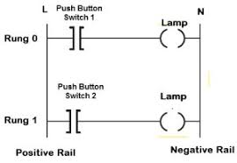
Fig 2.1 PLC Ladder Logic
In the above-mentioned example, two pushbuttons are used to control the same lamp load. When any one of the switches is closed, the lamp will glow.
The two horizontal lines are called rungs and the two vertical lines are called rails. Every rung forms the electrical connectivity between Positive rail (P) and Negative rail (N). This allows the current to flow between input and output devices.

2.3.2: Pump
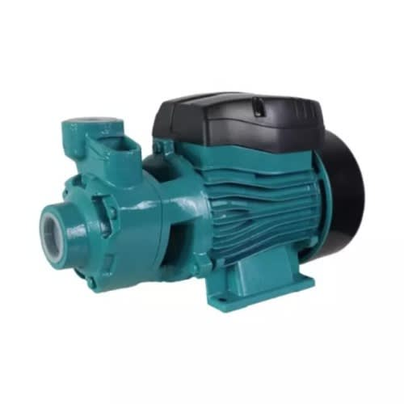
Fig 2.3: Pump

A 0.5 horsepower (0.5 HP) pump is a common type of electric water pump used in various applications, including residential, commercial, and industrial settings. The theory behind a 0.5 HP pump revolves around its capacity to move a specific volume of fluid, typically water, over a certain distance and against a particular resistance. Here's a theoretical overview of a 0.5 HP pump:

- Horsepower (HP):
- The term "horsepower" is a unit of power, and in the context of a pump, it represents the rate at which work is done. One horsepower is approximately equal to 745.7 watts. A 0.5 HP pump can deliver half of that power, or approximately 372.85 watts.

- Fluid Flow:
- A 0.5 HP pump is designed to move a specific volume of fluid per unit of time. This is often measured in gallons per minute (GPM) or liters per minute (LPM), and it depends on the design and efficiency of the pump. The pump's flow rate may vary based on factors like the pump type (centrifugal, diaphragm, submersible, etc.) and the specific application.

- Pressure Head:
- A pump generates pressure to move the fluid against resistance. This pressure is typically measured in pounds per square inch (PSI) or pascals (Pa). The pressure head generated by a 0.5 HP pump is determined by the design and impeller of the pump and the resistance it encounters in the system it's installed in.

- Application:
- The choice of a 0.5 HP pump is often based on the specific requirements of the application. In residential settings, it might be used for tasks like supplying water to a small household, boosting water pressure, or circulating water in a swimming pool. In commercial or industrial settings, it could be used for various purposes such as irrigation, heating and cooling systems, or as part of a larger fluid-handling system.

- Efficiency:
- The efficiency of a pump is a critical factor in its operation. A 0.5 HP pump should be designed to operate as efficiently as possible to minimize energy consumption and operating costs. Modern pumps incorporate design features and materials to enhance efficiency.

- Head and Flow Curve:
- A pump's performance is often represented by a head and flow curve, which illustrates how the pump behaves under various conditions. The curve shows the relationship between head (pressure) and flow (volume) at different operating points.

Pump Types:
- Different types of pumps (e.g., centrifugal, positive displacement, reciprocating) are available with varying characteristics. A 0.5 HP pump can be designed using different technologies to suit the specific application's requirements.

2.3.2 The Temperature Sensor(DS18B20)

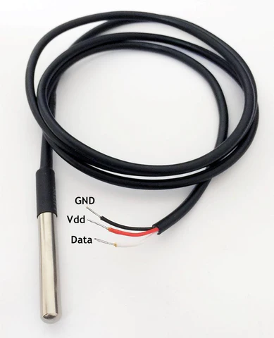

Fig 2.4:Temperature Sensor
The DS18B20 temperature sensor is a popular and versatile digital temperature sensor used in a wide range of applications. The theory behind the DS18B20 sensor revolves around its ability to accurately measure temperature and its unique one-wire digital communication protocol. Here's an overview of the theory behind the DS18B20 temperature sensor:
- Temperature Measurement:
- The core function of the DS18B20 sensor is to accurately measure temperature. It does so using a temperature-sensitive semiconductor integrated circuit, which exhibits a known and precise relationship between temperature and its electrical properties.

- Digital Output:
- The DS18B20 sensor provides a digital output, which is a distinct advantage in many applications. This digital output can be read and processed by microcontrollers, PLCs, and other digital devices.

- One-Wire Communication:**
- One of the key features of the DS18B20 sensor is its one-wire digital communication protocol. This protocol allows multiple DS18B20 sensors to be connected to a single data line while minimizing the number of connection wires needed. Each DS18B20 sensor has a unique 64-bit ROM code, which facilitates their identification on the one-wire bus.

- Resolution:
- The DS18B20 sensor offers user-selectable resolution options, ranging from 9 to 12 bits. Higher resolution provides more precise temperature measurements but requires more time to complete a reading.

In summary, the DS18B20 temperature sensor is a versatile and accurate digital sensor that uses semiconductor properties to measure temperature. Its one-wire digital communication protocol, resolution options, and unique features make it a popular choice for a wide range of applications, including environmental monitoring, industrial automation, and consumer electronics. Its accuracy, flexibility, and digital output make it a valuable tool for temperature sensing and control.

2.3.3 The Heater

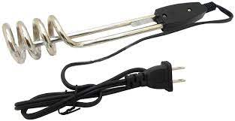

Fig 2.5:Water Heater

The theory of a heater is based on the fundamental principle of converting electrical energy into heat energy. Heaters are devices designed to raise the temperature of a specific area or substance, and their operation can vary depending on the type of heater. Here is a general overview of the theory behind heaters:

- Heating Element:
- At the core of any heater is a heating element. This element is typically made of a material that has high electrical resistance. When an electric current flows through this material, it encounters resistance, and as a result, the material heats up due to the Joule heating effect.

- Electrical Energy Conversion:
- Heaters rely on the conversion of electrical energy into thermal energy (heat). This process is governed by the principle that the power (in watts) dissipated as heat is equal to the product of the current (in amperes) squared and the resistance (in ohms) of the heating element, as described by the formula P = I^2R.

Types of Heaters:
- Heaters come in various types, each with its own theory of operation:
- Electric Resistance Heaters: These are the most common and operate by passing an electric current through a high-resistance wire or element.
- Induction Heaters:These use electromagnetic induction to heat conductive materials without direct electrical contact.
- Radiant Heaters: These emit infrared radiation to heat objects and people directly without heating the surrounding air.
- Convective Heaters: These use convection currents to circulate air over a heating element, warming the air, and then distributing it.
- Oil-Filled Heaters: These use a heating element immersed in oil to generate heat, and the oil retains heat, providing a longer-lasting source of warmth.

In conclusion, heaters operate on the fundamental principle of converting electrical energy into heat energy through the resistance of a heating element. The specific theory of operation varies depending on the type of heater and its intended application. Heaters are crucial devices for maintaining desired temperatures in various contexts, from domestic heating to industrial processes. The efficient operation and control of heaters play a significant role in energy conservation and comfort.

CHAPTER THREE
3.0 DESIGN AND ANALYSIS
With the need for a design of a steam production control process, we shall in this chapter analyze the components which will be required for this design and construction and also the specifications which they shall need to meet for the success of this project.
With the constraint of this project lying on its requirements for a fair knowledge of software engineering especially on the area of programming. A grounded knowledge of process control alongside A fair knowledge of panel wiring is also important together with Digital and analogue input/output and their conversions.
It is also necessary in the design of this project that certain requirements are taken into consideration, for instance:
i. Safety.
ii. Production/Running cost.
iii. Interfaces to a PC and possibly HMIs.
iv. Compatibility with common industrial electrical components.

In this project work, we shall be designing and eventually constructing a PLC based automatic boiler using the Mitsubishi FX2N-32MT which would be used in the Instrumentation Laboratory of the Petroleum Training institute for the purpose of simulating steam production control process.

To achieve success of this design work, it is extremely important that we consider each component in depth especially with regards to its power requirements and its compatibility with other components which we shall be using in the construction of this project work. We shall also be paying keen attention to safety and cost in our assessment of the components and their eventual selection.
3.1 DESIGN SPECIFIFCTIONS
The design of this PLC based level control system has the following components:
- The power supply unit.
- The controller unit.
- The conductors.
- The Heater.
- The Pump.
- The Level Sensor.
- The programming/Simulation.
3.2 DESIGN CONSIDERATION OF EACH COMPONENT
Considering the vast range of components available in the market with varying specifications. It has become of extreme importance we pay keen attention to ensure that components selection is done with not just safety and power requirements but also its compatibility with every other component we shall be using. With that in mind and with the knowledge of our desired output which is a training kit, we shall move ahead to detail the steps taken in the selection of our various components.
3.3 TOTAL CURRENT REQUIREMENT
It is of great importance that we make the selection of our components with keen attention to their power requirements. We shall have to understand the individual current requirement for the components and this shall be applied to determine our overall current requirement. Having this knowledge will be very helpful also in the selection of our power supply unit.
Current rating of the pump:3450mA
Current rating of the heater:6000mA
Current rating of the controller: 500mA
Current rating of Lamp: 1.5mA = 1.5mA
Current rating of Temperature sensor: 5.5mA = 5.5mA
Current rating of Level sensor: 1.8mA = 1.8mA
Total current = 9,958.8mA

3.4 THE POWER SUPPLY UNIT
The power supply was chosen to meet the requirement of supplying current to the entire system as no component of the system will be powered externally. The following specifications were used in the selection of the power supply:
Number of power supply: 1
Nominal input voltage: 220/240 VAC
Frequency: 50Hz
Output voltage: 110/220VAC
Factors considered in selecting the above output voltage: include the PLC input voltage, the Heater voltage requirements (220VAC) and the Pump voltage (110VAC). Since all voltages are equal, we choose the 110/220VAC output.
Output Power: 2199 watts
The output power was selected based on the power requirements of the various components used. The calculation for the output power can be found under each component.
3.5 THE CONTROLLER UNIT
For the purpose of this project, we shall be using the MITSUBISHI FX2N-32MT PLC as our controller. This component will be responsible for the control of all the components of the project which ranges from turning ON/OFF the process pump to control level to activating the LAL and LAH in case of system failures.

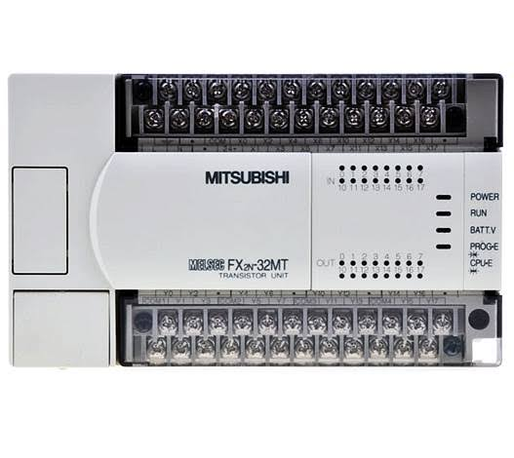
Figure 3.1 Pictorial diagram of the PLC
The PLC has the following specifications:
Number of PLC: 1
Dimension (W x H x D) mm: 150 x 90 x 87
Number of inputs: 24
Number of outputs: 16(Transistor)
Output type: Transistor
PLC Input voltage : 100 - 240 VAC
PLC Programming Interface: Computer
Operating current: 500mA
Input frequency: 50Hz
Power requirements: P=I x V
V=240V
I=500Ma/1000=0.5A
P=0.5x240
P=120watts
Connection cable: 2*1.5mm²
Programming Language: Ladder Logic
External memory module: Not Available
Program Capacity: 8000 Steps

3.6 THE CONDUCTORS
It is of extreme importance that the proper conductor sizing is selected. To achieve this, we would have to pay attention to the load requirement of the entire system.

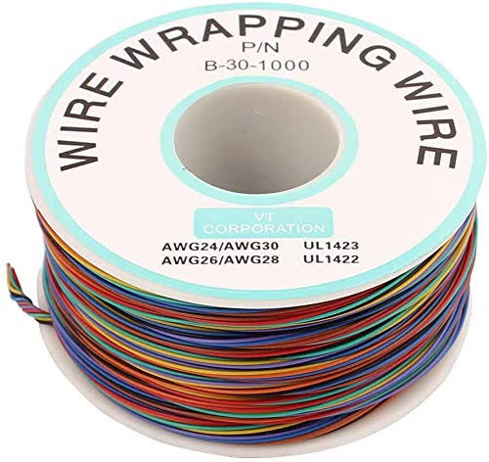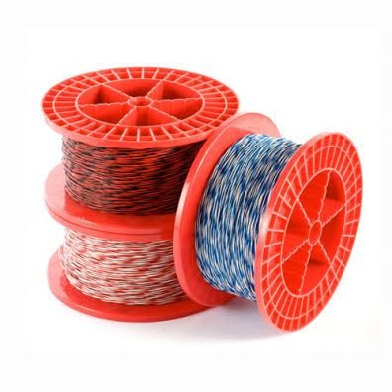

Figure 3.2 Diagram of the conductors (jumper wires)
The conductors shall be selected with respect to the following specifications.
Number of cables: 24
Voltage Requirement: 110/220VAC
Current Capacity: 200watts
Cable Lengths: 2mm²

3.7 THE INDICATOR LAMPS
These components shall be used in the automatic boiler to indicate the process going on in the process. It shall be designed to indicate the moment the system is turned ON, the level of process fluid in the process tank, the process of the controller (PLC) in the control of level in the process tank. There shall also be designated Lamps to indicate faults such as overflow in the process tank.

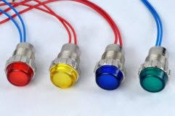
Figure 3.3 Diagram of the indicator lamps
The selection of the Lamps shall be based on the following specification:
Voltage Requirement: 110/220 VAC
Current Requirement:1.5mA
Dimensions: 3.46 × 2.72 × 1.02 inches
Mounting hole size: 8mm
Color: Red, Yellow and Green.

3.8 THE SWITCHES
For the purpose of this project work, we shall be considering the Push button switches. These are switches which are pushed to either activate or deactivate them. As they are going to be very important component of the project and shall serve to complete/connect or disconnect a circuit to start or stop a process. With the wide range of options in the market, it is very important we pay special attention in their selection.
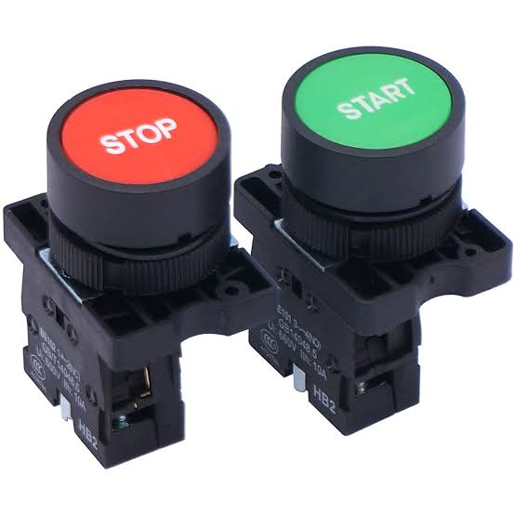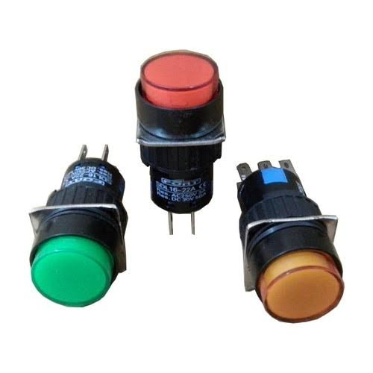
Figure 3.4 Diagram of the switches.
The following criteria shall be considered in the selection of our switches.
Voltage Requirement: 110VAC
Current Requirement: 1000mA
Number of Pins: 2
Colour of switches: Red and Black
Model of switches: Normally Open
Depth of switches: 16mm
Length of switches: 25mm

3.9 THE HOUSING STRUCTURE
This is the part of the project that shall serve to house (contain) the entire components being used in the construction of this project work. It is of utmost importance that we consider cost, mobility and material strength in selecting the material for our housing structure. The following requirements were considered in the selection of our housing structure:
- Cost of the material to be used.
- Strength of the material.
- Durability of the material.
- Ease of fabrication of the material.
Having considered the above points, we have decided to select metal as our most desired housing material. We shall be fabricating in the best possible way to economize space and also neatly contain all the components of the automatic boiler.
The sizing of the structure shall be designed to meet the below specification:
Width:
Height:
Area:
Length:

3.10 THE SOFTWARE DESIGN
In the software design of our automatic boiler control process, we shall be using a personal computer and Ladder Logic programming software (GX Developer) to write a ladder logic program which would be used to simulate the control process. This part is made up of two major structures which must be treated properly to ensure the success of this project work. They are:

ALGORITHM GENERATION
An algorithm is a statement of the procedure adopted in solving a problem. The supposed sequence of the system operation is stated below:
- Powering ON of the boiler.
- Powering ON/Booting of the Personal Computer.
- Starting up of the GX Developer and running of the program.
- Simulation of the Boiler Control process.
- End of the process.

- FLOW CHART
This is basically a chart that uses graphical representation to describe the proposed sequence of operation of this training kit.

Figure 3.5 Diagram of the entire system’s flow chart
3.11 THE PROGRAMMING/SIMULATION
In this part of the project work, we shall be using the Ladder Logic programming Language to write a program which would be applied to our project to simulate the control process. It is important to note that in the simulation of this project work, different programs can be written to achieve endless results but we shall be focusing on steam at 150degree celsius control using the Mitsubishi FX2N-32MT. This process can be further divided into three basic steps which are:

- THE PROGRAMMING
This is the point where we shall be using the ladder logic program to create a program that would simulate a real life experience of a steam control process. It shall involve the conveyor, the automatic discharge valve, the process tank, the timer, the controller.

Figure 3.6 Sample Diagram of a Ladder Logic Program
- THE IMPLIMENTATION STAGE
This involves the use of a personal computer and GX developer to test run the already written program. The system to be used shall be selected with respect to the GX developer requirements and its compatibility with the MITSUBISHI FX2N-32MT. After writing the program on our developer interface, we shall run it on the system to ensure that the process works seamlessly and efficiently before moving forward to implement it on the project.

3.2 Principle of operation of the circuit
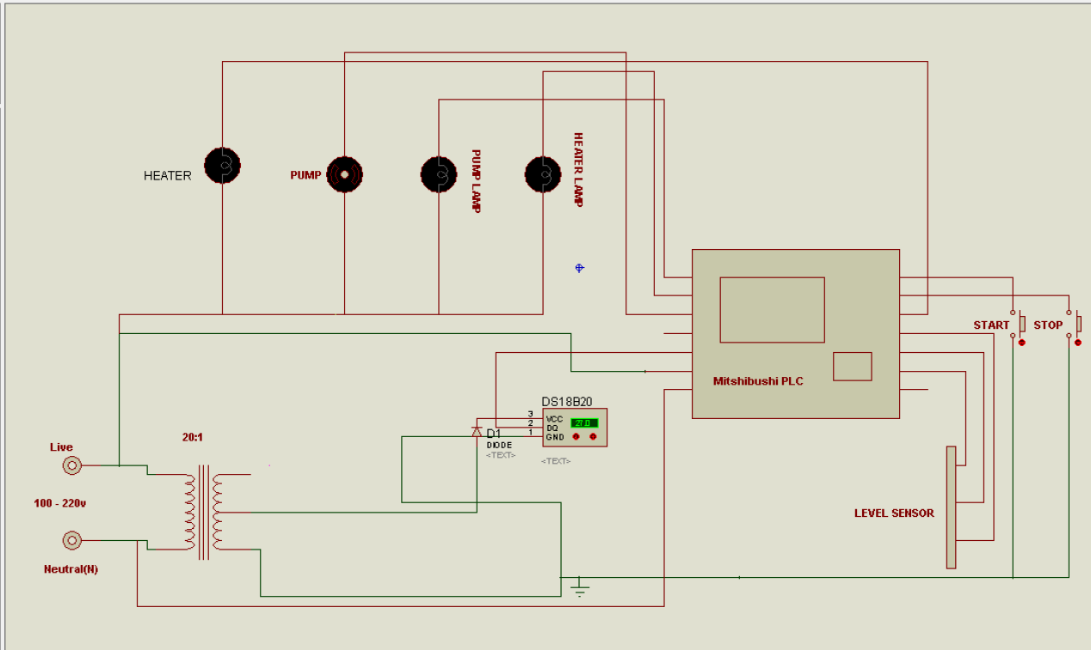

Fig 3.5: Circuit Diagram
The principle of circuit operation for an automatic boiler system using a Mitsubishi FX-series PLC, a pump, and a temperature sensor (DS18B20) involves the integration of these components to efficiently control and maintain the desired temperature within the boiler is as follows

1. Temperature Sensor (DS18B20):
- The DS18B20 is a digital temperature sensor that provides accurate temperature measurements. It is connected to the PLC via a digital input interface, typically using a 1-Wire communication protocol.

2. Mitsubishi FX-Series PLC:
- The Mitsubishi FX-series PLC serves as the control unit for the boiler system. It is programmed to read temperature data from the DS18B20 sensor and control the operation of the pump based on the measured level.

3. Control Logic:
- The PLC is programmed with control logic to maintain the desired temperature within the boiler. The control logic may involve the following steps:

- Read Temperature: The PLC reads the temperature data from the DS18B20 sensor at regular intervals.
- Read Level: The PLC reads the level data from the level sensor at regular intervals.

- Compare with Setpoint: The PLC compares the measured temperature with a predefined setpoint temperature (the desired boiler temperature).

- Control Action: Based on the comparison, the PLC determines whether the temperature is above, below, or within an acceptable range of the setpoint.

- Pump Control: If the level is below the setpoint, the PLC sends a signal to activate the pump. If the level is within the acceptable range or above the setpoint, the PLC may turn off the pump.

4. Pump:
- The pump, controlled by a relay or motor control module, circulates water within the boiler. When activated by the PLC, it pumps water into the boiler to increase the water level and turns off when the desired level is reached.

5. Feedback Loop:
- The system operates as a closed-loop control system. The temperature sensor continuously feeds back temperature data to the PLC, allowing the PLC to make real-time adjustments to the pump's operation.

CHAPTER FOUR
4.1 CONSTRUCTION
In this chapter, we shall be treating the construction of this project work. We shall be covering the details involved in the construction of the project starting from the measurements to the commissioning of the project. Alongside this, we shall also be treating the precautions taken in the construction of the system.
4.1.1 Components and their specification(tabulated)
S/N | NAME | SPECIFICATION
1 | FX-Series MItshibushi PLC | 12-I/O, AC 220volts
2 | Pump | 0.5hp, 110 ~220v AC
3 | Heater | 1000W,110 ~220v AC
4 | Temp Sensor | 0~180’C 0~20mA DC
5 | Switch | NC,NO
6 | Indicators | 220V AC , Green , Red
7 | Wires | Copper

4.1.2 Materials and Tools
Here we shall be listing the various tools and materials which shall be used in this project work construction.
- Materials
i. PLC
ii. Switches
iii. Lamps
iv. Casing
v. power cord
vi.Temperature sensor
- Tools
i. Drilling machine
ii. Handsaw
iii. Tape
iv. Multimeter
v. Screw drivers
vi. Plier
vii. Welding Machine

4.1.3 STEPS IN THE CONSTRUCTION OF THE PLC AUTOMATIC BOILER
In this section, we shall be treating the various steps taken in the construction of the project.
- Preparation of the PC
- Installation of the components
- Wiring of the components
- Commissioning of the project
- PREPARATION OF THE PC
At this stage, having purchased our Personal computer (the computer) following the consideration in chapter 3. The following steps were observed in preparing the PC for the control job:
- The PC was powered ON
- The PC was properly booted
- The GX Developer software was installed on the PC using the software disk and following the installation procedure.
- The program was run on the PC
- A test ladder program was written and stimulated on the GX Developer.
LADDER LOGIC PROGRAMMING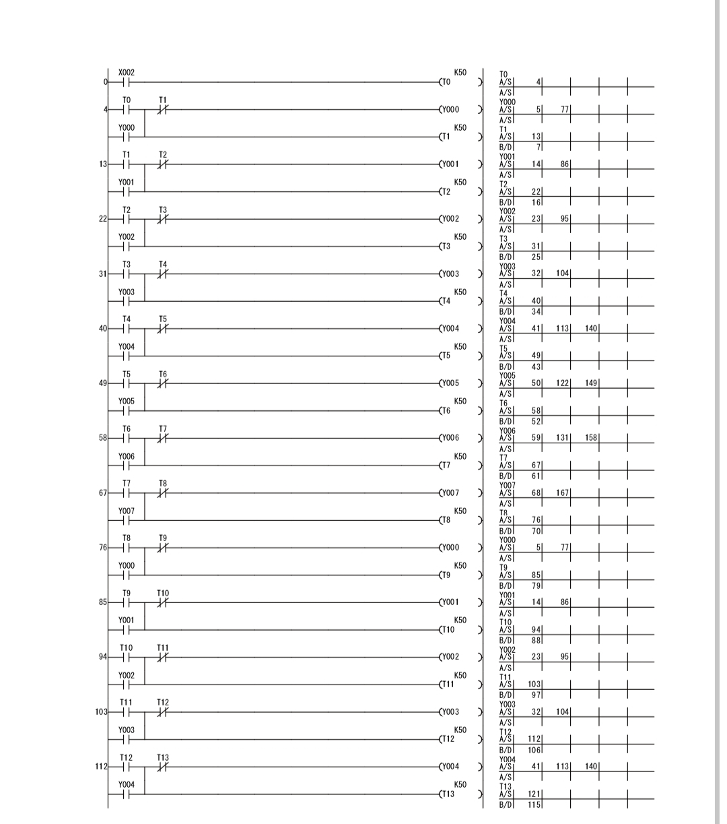
- INSTALLATION OF THE COMPONENTS
At this stage, we shall be treating the steps taken in arranging and placing the components in the housing structure/casing:
- The PLC was placed inside the casing and marked out using a pencil.
- The terminals were placed in the casing in their desired arrangement and marked using a pencil.
- The lamps were also arranged in the casing and marked using a pencil.
- We checked to ensure the casing could close effectively with the current arrangement made.
- We glued the PLC to the casing using gum.
- We allowed some moments for the PLC to stick firmly to the casing.
- We drilled a hole in the casing and installed the lamps and the terminals.
- WIRING THE COMPONENTS
In this stage, we made use of the jumper wires which was selected in chapter 3 to carry out our wiring operation. The wires were cut using pliers and soldered at the required points. To ensure clean soldering, excessive leads were removed from the soldered points.
- COMMISSIONING OF THE PROJECT
The following steps were taken in the commissioning of the project:
- The power cables was connected
- The network cable was connected
- The PC was turned ON.
- The programs were run on the project and its response was observed.
- The project was properly shut down.

4.1.4 CONSTRUCTION OF THE CASING

The casing was framed using metal sheet and metal rods
the pump was placed at the bottom left side of the structure,
the heater was embedded inside the tank desigened with metalic sheet .

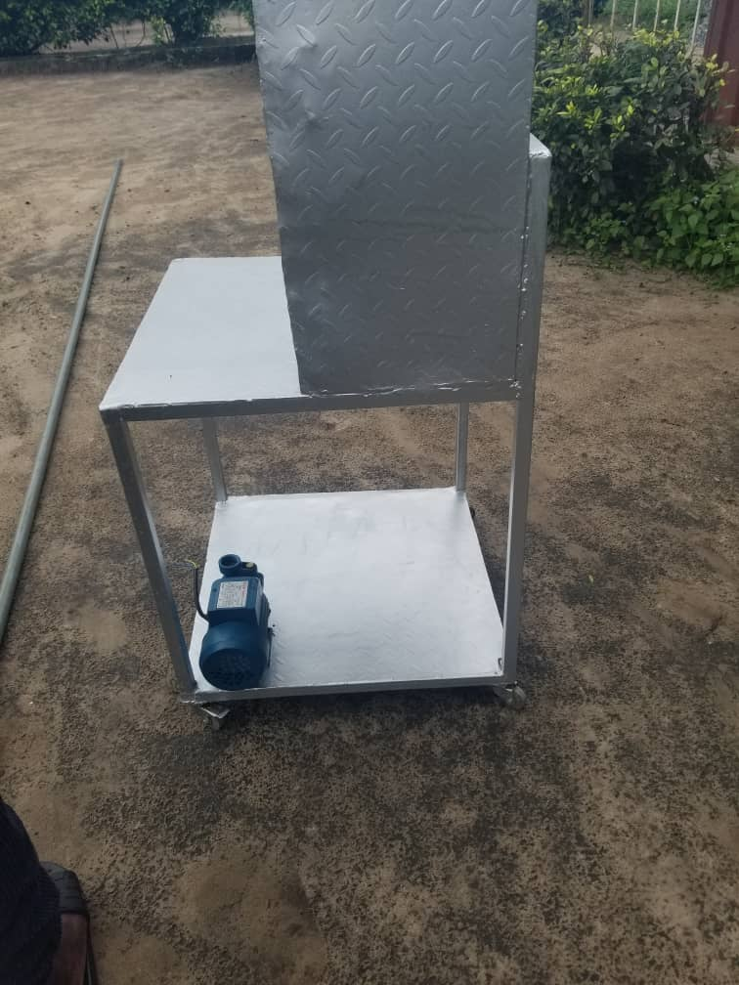
Fig 4.1: Rare View of the Automatic Boiler System
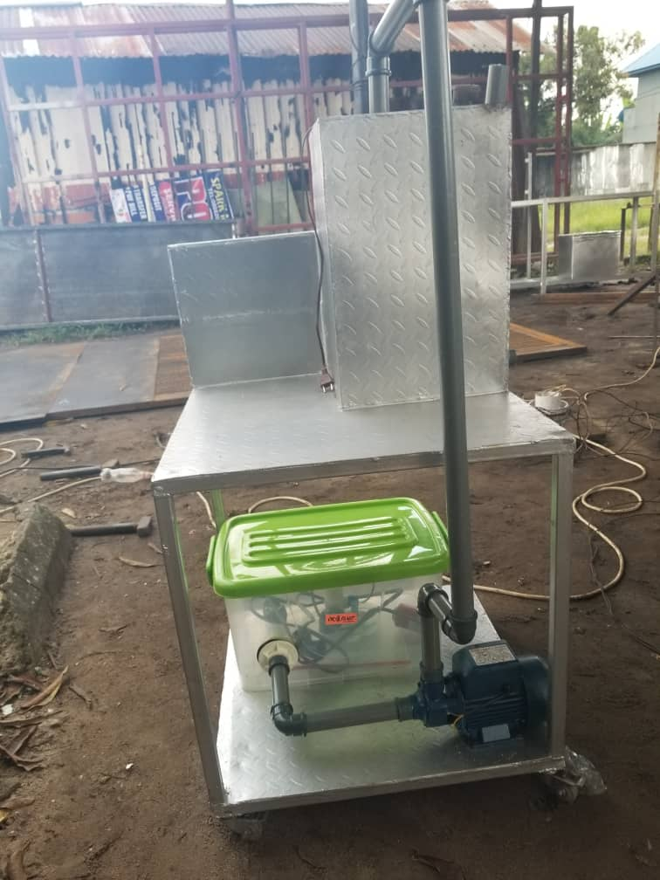
Fig 4.1:Front View of the Automatic Boiler System

4.2 TESTS RESULTS
The following tests were carried out and the following results were obtained:
Table 4.1: Test and Result
Test | Aim | Equipment  used | Result | Conclusion
Firmness test. | To ensure all components were tightly installed in the casing | Slight pulling | All the components were firmly installed as none pulled | All components were properly installed
Open Circuit test | To ensure there is no open circuit on the wiring done from one component to another | Digital Multimeter | All the test points read R>1Ω | There is no open circuit in the connection therefore the connection was properly done
Insulation test | To ensure there is no leakage current from any of the components to the casing of the project | Digital Multimeter | There was no continuity at all the test point which means there is no leakage current | There is no leakage current therefore insulation is perfect.
Short Circuit Test | To ensure there is no short circuit on the wiring done from one component to another. | Digital Multimeter | All the test points read R>1Ω. | There is no short circuit in the connection therefore the connection was properly done
Operation test | To ensure the system was working efficiently | The system was powered ON and the programs were run and were observed on the project. | Operated as required | System is in good operating condition.

Table 4.3: Bill of engineering material(BEME)
S/N | DESCRIPTION OF ITEM | QTY | UNIT PRICE (N) | TOTAL PRICE  (N)
1 | MITSUBISHI FX-1s-20MR 001 | 1 | 150,000.00 | 150,000.00
2 | Switch | 2 | 150.00 | 300.00
3 | Indicator Lamp | 3 | 200.00 | 600.00
4 | Voltage Regulator | 1 | 500.00 | 500.00
5 | Casing | 1 | 120,000.00 | 120,000.00
6 | Power supply (power pack) | 1 | 8,000.00 | 8,000.0
7 | Pump | 1 | 30,0000 | 30,000
 | TOTAL |  | 308,000.00 | 309,000.00

CHAPTER FIVE
5.1 CONCLUSION

In conclusion, the Mitsubishi FX PLC-based automatic boiler system represents a significant advancement in industrial automation and control technology. This system combines the reliability and precision of Mitsubishi PLCs with the efficiency and safety of a modern boiler system. Its ability to monitor, control, and optimize boiler operations in real-time ensures stable and energy-efficient performance while minimizing the risk of accidents.

The Mitsubishi FX PLC's robust features and user-friendly programming interface make it a versatile choice for industrial applications. It can adapt to various boiler configurations and easily integrate with other automation systems. Furthermore, its diagnostic and troubleshooting capabilities enhance the system's reliability, reducing downtime and maintenance costs.

With the Mitsubishi FX PLC-based automatic boiler system, operators and engineers can rely on an intelligent and responsive control system that not only ensures optimal energy utilization but also contributes to environmental sustainability. This technology not only offers peace of mind in terms of safety and efficiency but also positions your facility for a competitive edge in the rapidly evolving industrial landscape. Mitsubishi's commitment to innovation and quality control makes this system a reliable choice for your industrial heating needs.

5.2 RECOMMENDATION

Recommendations for future improvements in a Mitsubishi FX PLC-based automatic boiler system:

1. Real-Time Monitoring and Reporting:
Develop a more comprehensive and user-friendly real-time monitoring and reporting interface. This should include predictive maintenance tools, alarms, and alerts to provide operators with immediate insights into system performance and potential issues.

2. Remote Accessibility:
Enable remote access to the system for authorized personnel. This feature can enhance system management and troubleshooting capabilities, allowing experts to diagnose and address issues without being physically present on-site.

3. Integration with IoT:
Consider integrating the system with the Internet of Things (IoT) technology. This would enable data collection and analysis from a broader range of sensors and devices, providing more detailed insights into boiler performance and energy efficiency.

4. Energy Efficiency Optimization:
Develop algorithms and control strategies to further optimize energy efficiency. This might include load forecasting, adaptive control, and better utilization of waste heat to reduce energy consumption and greenhouse gas emissions.

5. Enhanced Human-Machine Interface (HMI):
Improve the HMI to make it more intuitive and user-friendly, allowing operators to interact with the system more efficiently. Incorporate touchscreens, data visualization, and customizable dashboards to enhance the user experience.

6. Integration with Renewable Energy Sources:
Consider incorporating the capability to integrate renewable energy sources like solar or wind power into the system. This would reduce reliance on non-renewable resources and promote sustainability.

7. Redundancy and Fail-Safe Systems:
Implement redundant systems and fail-safe mechanisms to ensure uninterrupted boiler operations, especially in critical industrial processes where downtime can lead to substantial financial losses.

8. Documentation and Training:
Provide comprehensive documentation and training for system operators and maintenance personnel. This will ensure that the system is used to its full potential and that maintenance and troubleshooting are carried out effectively.

9. Environmental Compliance:
Keep up to date with environmental regulations and standards to ensure the system remains in compliance. Consider features that automatically adapt to changing emissions requirements and provide detailed emissions reporting.

